1. Ổn định tổ chức: (1 phút)
- Kiểm tra sĩ số lớp học: điểm danh học sinh vắng mặt.
GV: Monitor, is there any students absent today?
SV: No, Madam. We are all here.
- Nội dung nhắc nhở học sinh: Các em nghỉ học tuần trước cần cố gắng nghe
giảng hơn.
GV: Good. …., you were absent last time so try harder to understand the lesson.
SV: Yes, Madam.

Kiểm tra bài cũ:
Part 1: Label the part of a car interior.
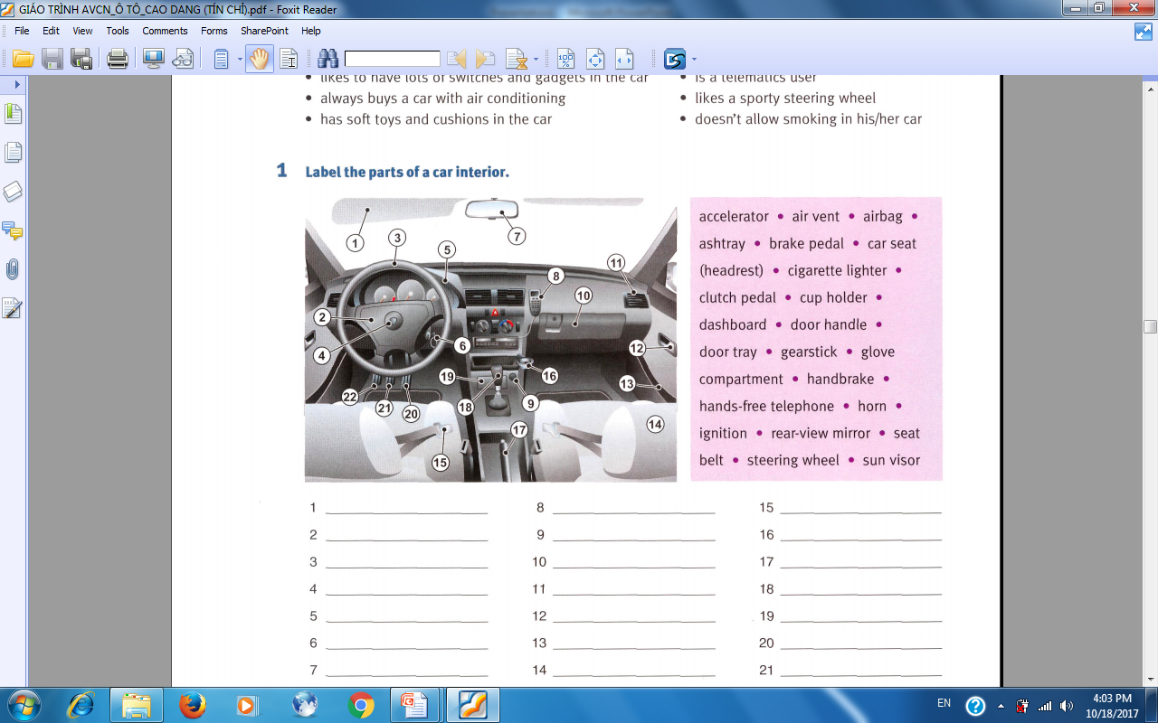

1. sun visor: tấm che nắng
3. steering wheel: vô lăng
5. dashboard: bảng đồng hồ

7. rear view mirror: kính chiếu hậu
8. hands free telephone: điện thoại rảnh tay
10. glove compartment: ngăn đựng đồ
11. air vent: cửa gió máy điều hoà

12. door handle: Tay nắm mở cửa
13. door tray: Khay đựng đồ ở cửa
14. car seat: Ghế xe
headrest: gối dựa đầu

16. cup holder: giá để ly
9. cigarette lighter: đồ mồi thuốc lá
17. handbrake: thắng tay

6. ignition: công tắc đề
19. ashtray: gạt tàn thuốc
18. gear stick: cần số
15. seat belt: dây an toàn

20. Accelerator: bàn đạp ga
21. brake pedal: bàn đạp thắng
22. clutch pedal: bàn đạp côn
4. horn: còi
2. airbag: túi khí

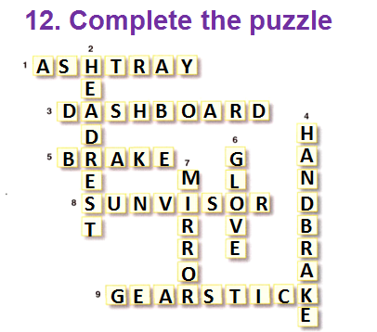
GV : -Who can?
-Who volunteers?
- Can you guess?
- Can you spell? (đánh vần)
-What does it mean? (nghĩa là gì?)

* Part 13: reading
Read the magazine article and answer the questions which follow.

I. Giới thiệu bài (warm up)
Giảng viên chia SV ra làm 2 nhóm và yêu cầu ghép bức tranh với 7 từ cho sẵn trong vòng 1 phút. Sau đó từng SV sẽ ghép đáp án lên bảng.

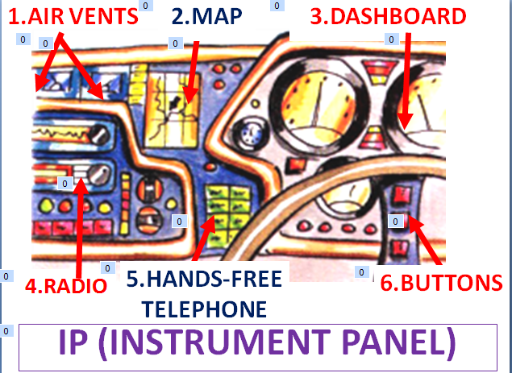

II. Đọc bài (Read aloud) SV nghe và dò theo.
III. Phân tích bài (Analys)
I. Skim the text and choose the main idea for each paraghrap.
A. The best solution to clear the IP considered by some engineers.
B. The introduction of the IP.
C. Voice recognition is one of the solution if it is not used too much.
D. Touch screens are replaced by some space-eaters.
E. Some solutions to make the IP simple.
P1 B
P2 E P3 C
SV Phân tích lý do chọn:
Đoạn 1: The first sentence is about the things on the IP. The second is about what the designers and engineers do for the IP. And the customers think about the IP in the last sentence.

Đoạn 2: The first sentence “Designers deal with the problem in various ways” is the same with that sentence.

Đoạn 3: In first sentence” voice recognition as a way to get rid of many manual controls”.

Hai câu sai vì: Câu A: No best solution is mentioned.
Câu D: Touch screens and Space-eaters need to change the position.
(màn hình cảm ứng và những thiết bị tốn chỗ phải đổi chỗ cho nhau mới đúng)

2. Read the text and answer these questions.
a. What are on the IP?
1 Heating and cooling systems
2 Navigation aids
3 Audio system features
4 Station pre-set buttons
5 Telematics equipment
6 Standard instruments

b. Is this IP simple or overcrowded?
It’s overcrowded.

c. Why do they need to keep the IP simple?
So that the driver is not distracted (sao nhãng) (by too many buttons and instruments).
Customers equate a spaciuos interior with luxury.
(khách hàng đánh đồng 1 nội thất rộng rã với sự sang trọng)

d. What are the 4 solutions to make the IP simple?
- Reduce the size (of space-eaters)
- Remove them.
- Use touch screens.
- Use voice recognition.

e. What are the problems of touch screens and how to solve them?
- If they are overcrowded , they can distract the drivers and cause accidents.
Make them as simple as possible.
- If they are too high, it’s hard to read because of reflections and the sun ’washing out’ the screen.
put them as high as the dashboard.
3. True/ False Excercise
a. Voice recognition is a way to get rid of many manual controls. (T)
b. We should put the touch screens lower than the dashboard. (F)
c. The drivers can drive easily with the IP with too many buttons and instruments.(F)
d. Designers and engineers try to simplify the IP. (T)
e. The IP should look overcrowded. (F)

Correct the false ones.( Sửa câu sai)
b. We should put the touch screens as high as the dashboard.
c. The drivers can not drive easily with the IP with too many buttons and instruments.
e. The IP should not look overcrowded.

*Speaking: Discuss 2 questions in pairs.
1. Which do you prefer – an IP that looks like a cockpit with lots of switches and controls, or a more simplified version? Why?
I prefer the simplified version. Because it looks more beautiful and luxurious.

I prefer the simplified version, too. I think it’s easier for me to drive and control.

I prefer the second one because it’s simpler and more spacious. I make me feel safer and easier while driving.

2. How do you feel about voice recognition controls?
It’s really good. I think it can help us control many things with our voice.
It’s perfect but we shouldn’t use it too much because we can confuse the orders.
Voice recognition is one of the best inventions of mankind. It helps us reduce manual controls and focus on driving.

